**Klarna Payments**

Version 17.4.0



Table of Contents

1. Summary 1-3

2. Component Overview 2-4

2.1 Functional Overview 2-4

2.2 Use Cases 2-4

2.3 Limitations, Constraints 2-4

2.4 Compatibility 2-4

2.5 Privacy, Payment 2-4

3. Implementation Guide 3-5

3.1 Setup 3-5

3.2 Configuration 3-5

3.3 Custom Code 3-5

3.4 External Interfaces 3-5

3.5 Testing 3-5

4. Operations, Maintenance 4-6

4.1 Data Storage 4-6

4.2 Availability 4-6

4.3 Support 4-6

5. User Guide 5-7

5.1 Roles, Responsibilities 5-7

5.2 Business Manager 5-7

5.3 Storefront Functionality 5-7

6. Known Issues 6-8

7. Release History 7-9

# Summary

This cartridge enables a Commerce Cloud store to use the Klarna Payments service.

The developer has to install the cartridge and integrate it into online store following the instructions from this document. It is mandatory that the merchant has to open an account with Klarna and configure some items in Commerce Cloud Business Manager to make the integration working properly.

Klarna offers a test environment, so the integration can be tested before switching to the Klarna production environment.

The integration consists of an archive, which contains the following contents:

* Cartridge called ‘int_klarna_payments’, and optionally either "int_klarna_payments_pipelines" or "int_klarna_payments_controllers" depending on which architecture is to be employed.
* A site-template archive containing new attributes and settings
* This document

The integration is based on the Site Genesis demo store provided by Commerce Cloud.

# Component Overview

## Functional Overview

<BUSINESS/FUNCTIONAL OVERVIEW OF COMPONENT, INCLUDING FLOW CHARTS, DIAGRAMS WHERE APPLICABLE>

## Use Cases

<USE CASES COVERED BY THE COMPONENT>

## Limitations, Constraints

<WHICH PARTS OF THE 3RD PARTY OFFERING ARE NOT SUPPORTED>

<WHICH DEMANDWARE FEATURES OR CONFIGURATIONS ARE NOT SUPPORTED, E.G. MULTIPLE LOCALES, NON-US SHIPPING ADDRESSES, ORDERS WITH MORE THAN ONE SHIPPING ADDRESS, CATALOG SIZE LARGER THAN 500K>

<IF YOUR INTEGRATION REQUIRES A CUSTOM CATALOG FEED, DESCRIBE ANY LIMITATIONS ON PRODUCT ATTRIBUTES, SUCH AS NON-SUPPORTED HTML ATTRIBUTES, 0.00$ PRICES, ONLY ORDERABLE PRODUCTS EXCLUDING BACKORDER>

## Compatibility

<AVAILABLE SINCE DEMANDWARE X.Y.Z>

<DEMANDWARE VERSION REFERENCED FOR INTEGRATION INTO STOREFRONT (REFERENCE APPLICATION) AND USED IN SCREENSHOTS>

## Privacy, Payment

<INDICATE IF CUSTOMER PROFILE DATA IS BEING ACCESSED, IF CREDIT CARD DATA IS BEING PROCESSED OR STORED WITHIN DEMANDWARE>

# Implementation Guide

To setup and implement Klarna Payments Salesforce Commerce Cloud Cartridge, the below steps must be followed:

## Setup

<LIST CARTRIDGES THAT ARE PART OF THE COMPONENT AND ENTRY POINTS/PARAMETERS (API) IN DETAIL>

<HIGHLIGHT WHAT CARTRIDGES NEED TO BE DEPLOYED TO PRODUCTION, WHAT ARE FOR TESTING, WHAT SHOW CUSTOM CODE EXAMPLES (E.G. FOR STOREFRONT INTEGRATION)>

Klarna Payments integration has three cartridges:

* int_klarna_payments which implements the core storefront functionality;
* int_klarna_payments_pipelines which implements the storefront functionality with pipeline based approach;
* int_klarna_payments_controllers which implements the storefront functionality with controllers based approach;

### int_klarna_payments

The int_klarna_payments cartridge has the following components:

**Cartridge name**

* *int_klarna_payments*

**Forms**

**Pipelines**

**Scripts**

**Static**

**Templates**

**Resources**

**Webreferences**

**Metadata**

### int_klarna_payments_pipelines

The *int_klarna_payments_pipelines* cartridge has the following components:

**Cartridge name**

* *int_klarna_payments_pipelines*

**Forms**

**Pipelines**

**Scripts**

**Static**

**Templates**

**Resources**

**Webreferences**

**Metadata**

### int_klarna_payments_controllers

The *int_klarna_payments_controllers* cartridge has the following components:

**Cartridge name**

* *int_klarna_payments_controllers*

**Forms**

**Pipelines**

**Scripts**

**Static**

**Templates**

**Resources**

**Webreferences**

**Metadata**

## Configuration

*<CONFIGURATION STEPS INCLUDING ASSIGNMENT OF CARTRIDGES TO SITE, CUSTOM PREFERENCES, SET UP OF JOB SCHEDULES, CONFIGURATION DIFFERENCES FOR DIFFERENT INSTANCE TYPES, IMPORT OF METADATA>*

### Cartridge Path

If using the controller based integration, cartridge path should be setup as such under Sites / Manage Sites /

app_storefront_controllers:app_storefront_core:int_klarna_payments_controllers:int_klarna_payments

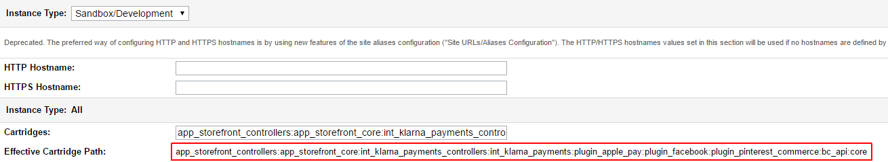

If using pipelines, the cartridge path should be similar to:

app_storefront_pipelines:app_storefront_core:int_klarna_payments_pipelines:int_klarna_payments

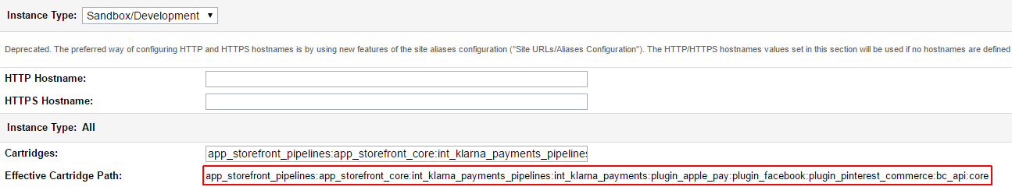

### Klarna Payments Configurations

Also, there is a page in Business Manager where you have to configure Klarna Payments cartridge, you can find it in Site Preferences > Custom Preferences > Klarna_Payments:

**TODO: add screenshot**

Here is the description of the Site Preferences fields which have to be configured:

|  |  |  |
| --- | --- | --- |
| **Parameter Name** | **Attribute ID** | **Description** |
| Send product_url and image_url | sendProductAndImageURLs | If set to true product_url and image_url fields in Klarna Payments create session call will be included in API call, otherwise product_url and image_url fields will not be populated. |
| merchant_reference2 mapping | merchant_reference2 mapping | The field from SCC order (basket) object that is mapped to merchant_reference2 field from klarna API request.  Has to be a string corresponding to the names of SCC LineItemCtnr class attributes. |
| Pre-Assesement is on for: | kpPreAssessment | Pre-assessment flag. Comma separated string values with country codes, which should have the pre-assessment flag ON. For example the following flue “UK, CN, AU” would mean the pre-assessment is on for United Kingdom, China and Australia |
| Border Color Preference | kpColorBorder | CSS hex color to be used in Klarna Payments iFrame |
| Border Selected Color Preference | kpColorBorderSelected | CSS hex color to be used in Klarna Payments iFrame |
| Button Color Preference | kpColorButton | CSS hex color to be used in Klarna Payments iFrame |
| Button Text Color Preference | kpColorButtonText | CSS hex color to be used in Klarna Payments iFrame |
| Checkbox Color Preference | kpColorCheckbox | CSS hex color to be used in Klarna Payments iFrame |
| Checkbox checkmark color preference | kpColorCheckboxCheckmark | CSS hex color to be used in Klarna Payments iFrame |
| Details Color Preference | kpColorDetails | CSS hex color to be used in Klarna Payments iFrame |
| Header Color Preference | kpColorHeader | CSS hex color to be used in Klarna Payments iFrame |
| Link Color Preference | kpColorLink | CSS hex color to be used in Klarna Payments iFrame |
| Text Color Preference | kpColorText | CSS hex color to be used in Klarna Payments iFrame |
| Secondary Text Color Preference | kpColorTextSecondary | CSS hex color to be used in Klarna Payments iFrame |
| Border Radius Preference | kpRadiusBorder | Size (in pixels) of the border radius to be used in Klarna Payments iFrame |

### Services Configuration

### Custom attributes

ORDER system object has been extended with custom attribute kpOrderID of type string, which is holding the Klarna Payments Order ID, if Klarna Payments is used for the specific order

## Custom Code

Integration may vary based on the customers' storefront. Site Genesis version 2 is used to demonstrate Klarna Payments integration.

### Templates modifications

To integrate Klarna Payments the following storefront cartridge templates should be updated:

* + - default/checkout/billing/billing.isml
    - default/checkout/billing/paymentmethods.isml

**default/checkout/billing/billing.isml**

Add Code:

<script><isinclude template="/resources/klarnapaymentsresources.isml"/></script>

<script type="text/javascript" src="${URLUtils.staticURL('/js/klarna-payments.js')}"></script>

<script src="https://credit.klarnacdn.net/lib/v1/api.js" async></script>

Before</isdecorate> closing tag as shown below:

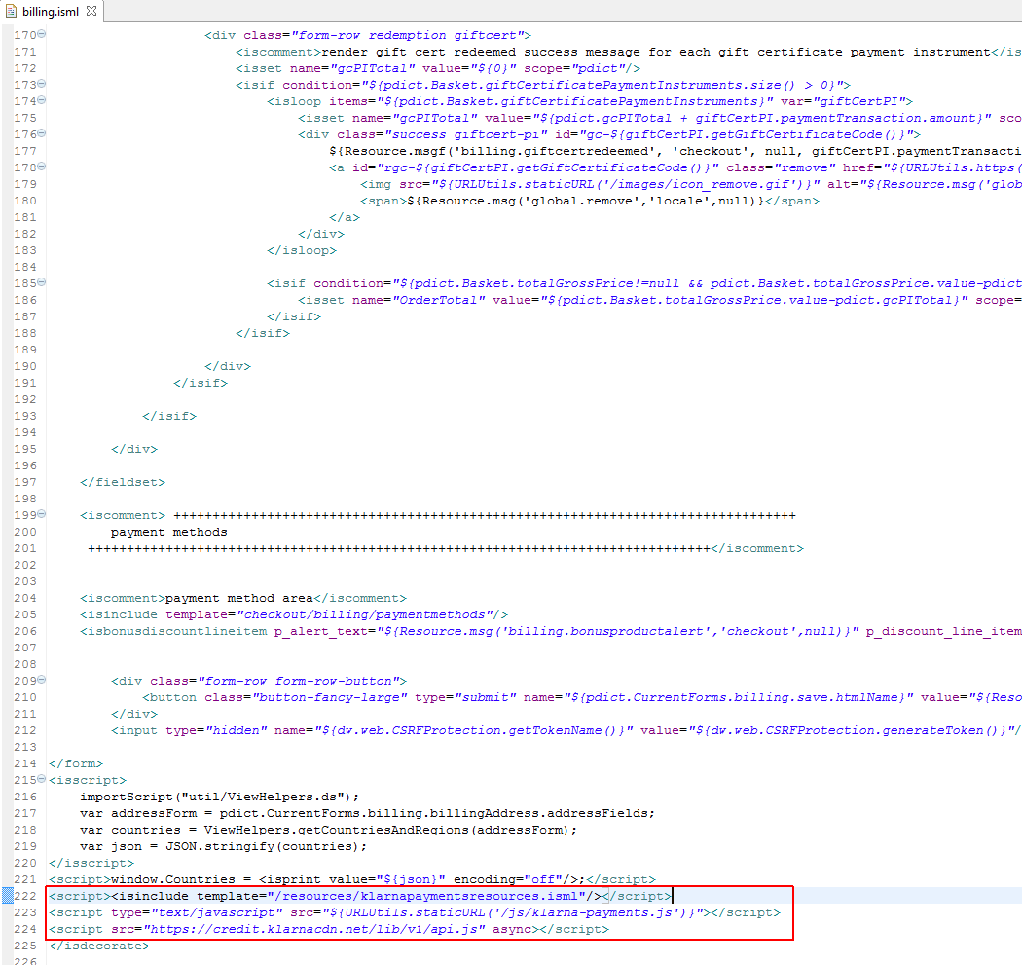

Add Code:

<input type="hidden" name="klarna_payments_authorization_token" value=""/>

Before</form> closing tag as shown below:

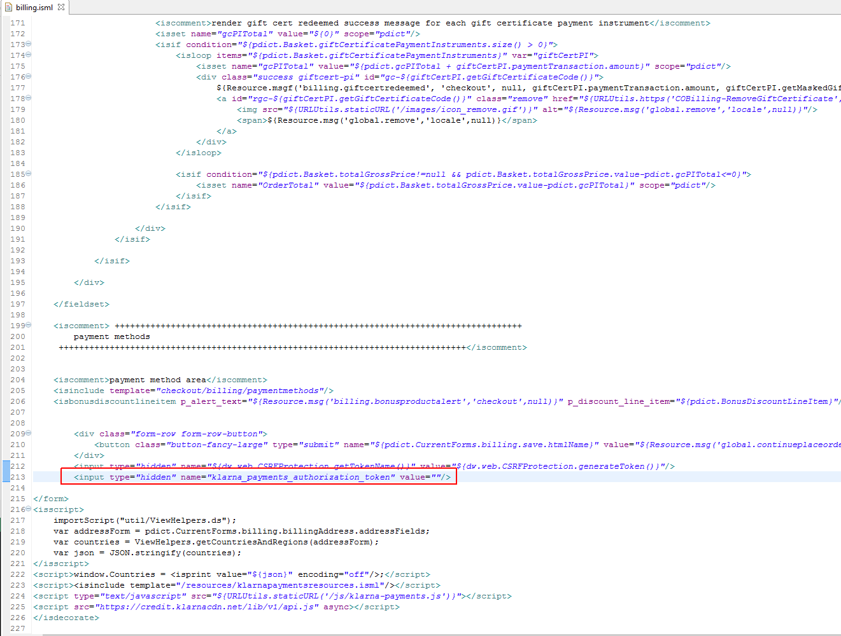

**default/checkout/billing/paymentmethods.isml**

Add Code:

<iscomment>Klarna Payments Processor</iscomment>

<div class="payment-method <isif condition="${!empty(pdict.selectedPaymentID) && pdict.selectedPaymentID=='PayPal'}">payment-method-expanded</isif>" data-method="Klarna">

<div id="klarna_payments_container">

</div>

Before</fieldset> closing tag as shown below:

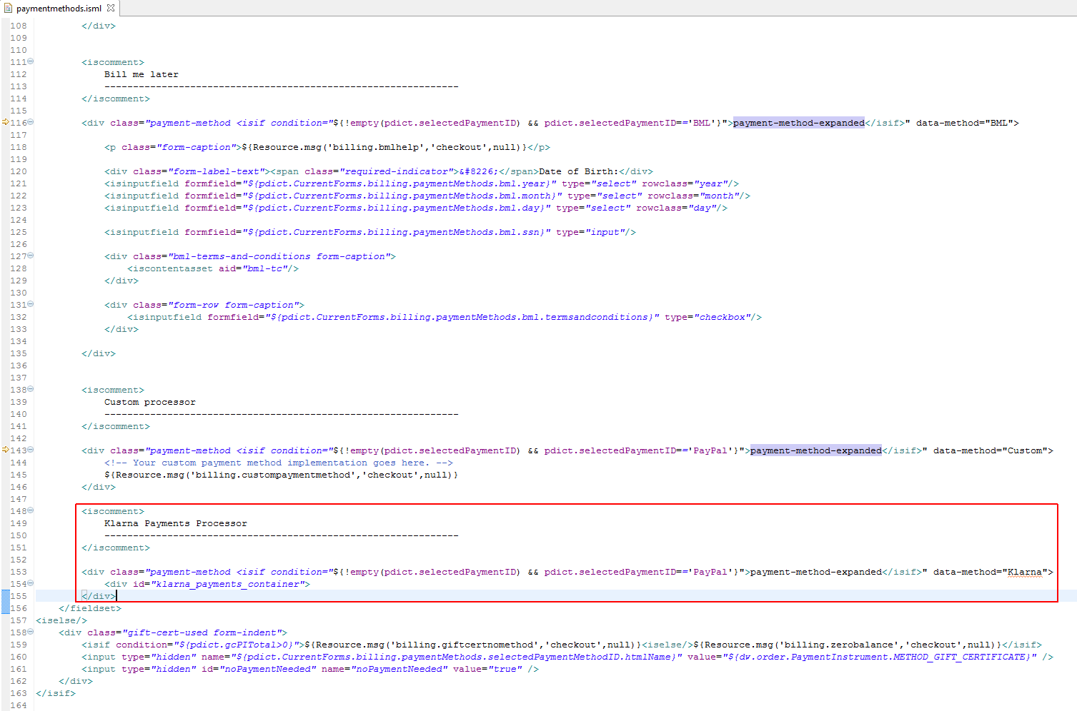

### Pipeline modifications

To use Klarna Payments cartridge you will need to make the following changes in pipelines.

### COBilling pipeline. Go to COBilling pipeline, Start node and add KLARNA_PAYMENTS-CreateSession call node entry point before checkout/billing/billing -> Billing interaction continue node (see screen shot below)

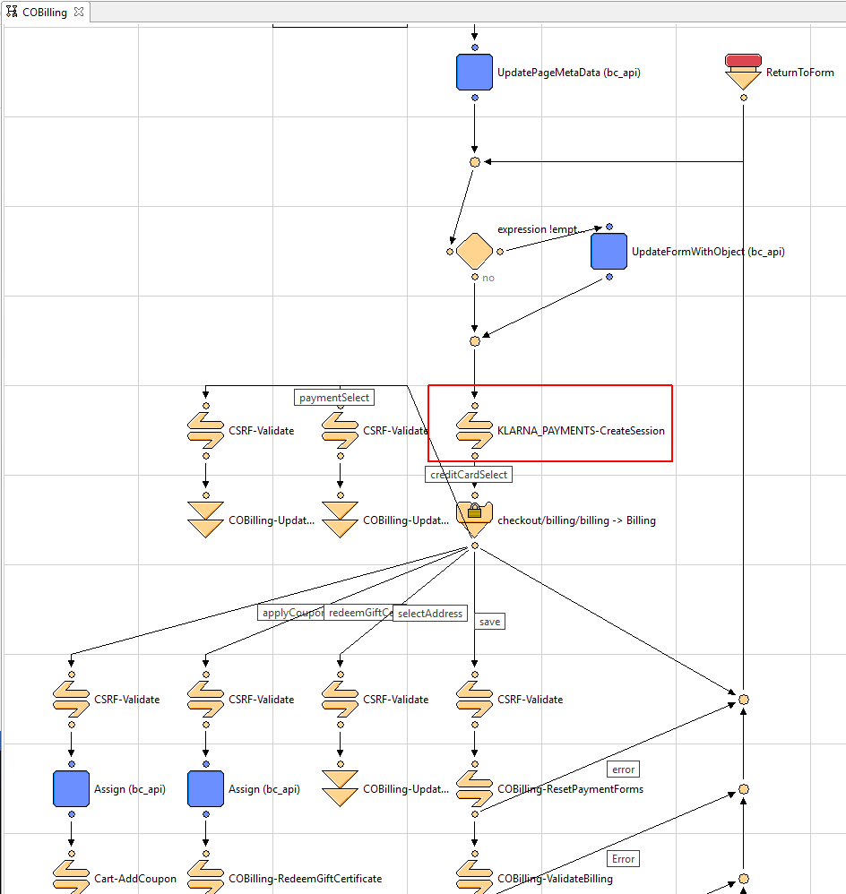

### COSummary pipeline. Go to COSummary pipeline, Submit node and add KLARNA_PAYMENTS-Redirect call node entry point before COSummary-ShowConfirmation jump node (see screen shot below)

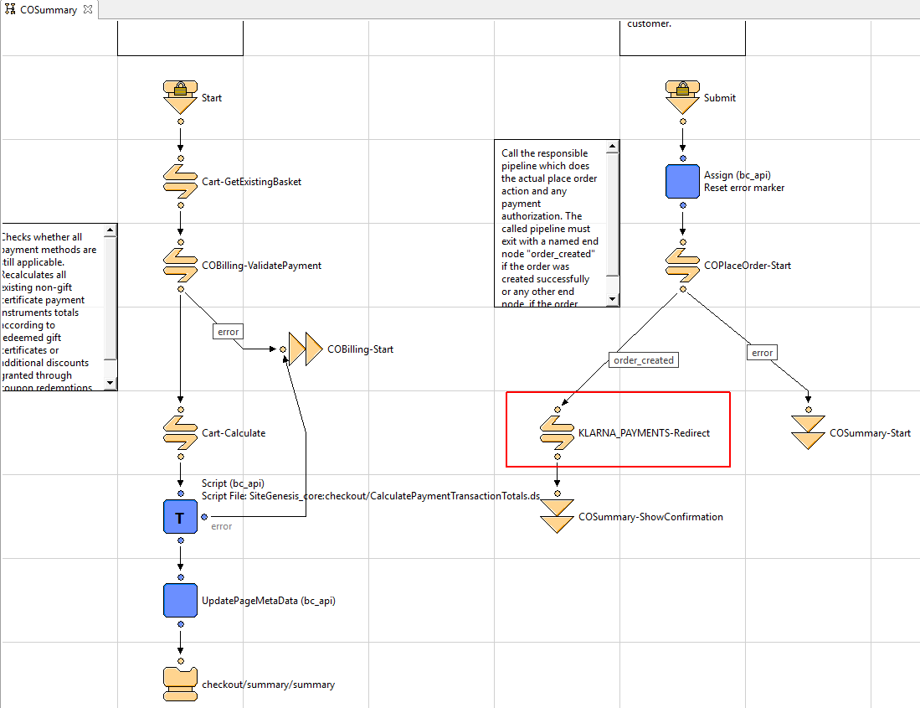

### COPlaceOrder pipeline. Go to COPlaceOrder pipeline, PlaceOrder node and add KLARNA_PAYMENTS-PendingOrder call node entry point before PlaceOrder script node node (see screen shot below). Create ‘pending’ and ‘error’ transitions and end nodes as shown on the screenshot

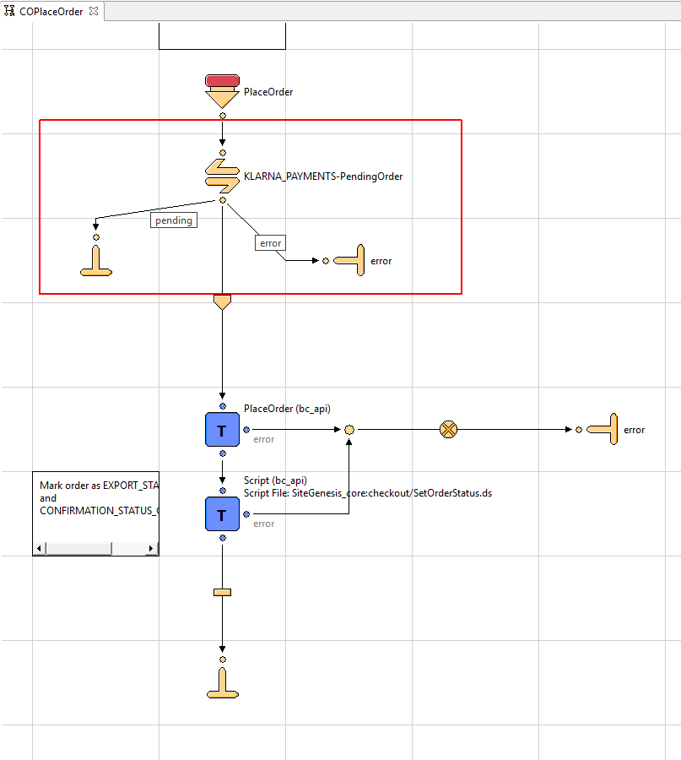

<IF STOREFRONT APPLICATION NEEDS TO BE MODIFIED, EXPLAIN STEPS RELATIVE TO REFERENCE APPLICATION>

<IF ADDITIONAL CUSTOM CODE NEEDS TO BE WRITTEN, EXPLAIN IN DETAIL AND PROVIDE EXAMPLE.>

*<ESTIMATED INTEGRATION EFFORTS>*

*Checkout/billing*

## External Interfaces

<INTERFACES TO EXTERNAL SERVICES, E.G HTTP CLIENT, WEBSERVICE CALLS, DESCRIPTION OF REQUESTS AND RESPONSES>

## Testing

*<SAMPLE DATA, TEST ACCOUNT, TEST CASES, REFERENCE TO CERTIFICATION REQUIREMENTS>*

# Operations, Maintenance

## Data Storage

*<DESCRIBE ANY DATA THAT WILL BE STORED WITHIN DEMANDWARE, E.G. CUSTOM OBJECTS, INCLUDING DURATION AND CLEANUP JOBS IF APPLICABLE>*

<IS THERE A SEPARATE DATA STORAGE OUTSIDE OF DEMANDWARE, SPECIFY LOCATION AND DURATION IF APPLICABLE>

## Availability

<EXPECTED AVAILABILITY /UPTIME OF ANY EXTERNAL SERVICE, INTERFACES>

<FALLBACK SOLUTION, BEHAVIOR IF EXTERNAL SERVICES ARE NOT AVAILABLE, IMPACT ON CUSTOMER STOREFRONT>

<ANY EXISTING UTILITIES THAT HELP TO DETECT AVAILABILITY/UPTIME OF EXTERNAL SERVICE, E.G. WEBSERVICE CALL, GOMEZ PING>

<ESTIMATED PERFORMANCE METRICS FOR PEAK BUSINESS HOURS IF AVAILABLE>

<NOTIFICATION PROCESS IF EXTERNAL SERVICES, INTERFACES ARE NOT RESPONDING, E.G. HOTLINE /SUPPORT PHONE NUMBER>

## Support

<CONTACT PERSON IN CASE DEFECT FIXES OR IMPROVEMENTS FOR COMPONENT ARE REQUIRED>

# User Guide

## Roles, Responsibilities

*<LIST RECURRING TASKS THAT NEED TO BE FULFILLED BY CUSTOMER, MERCHANT TO RUN THE INTEGRATION, E.G. MANUAL FEED OF CATALOG DATA INTO 3RD PARTY SERVICE, IF APPLICABLE>*

## Business Manager

<UI SCREENSHOTS AND DESCRIBTION OF FUNCTIONALITY>

<DESCRIBE NEW BUSINESS MANAGER MODULES AND CONFIGURATION OPTIONS IF APPLICABLE>

## Storefront Functionality

*<DESCRIBE NEW STOREFRONT FUNCTIONALITY>*

# Known Issues

*<LIST KNOWN ISSUES AND WORKAROUNDS>*

# Release History

<RELEASE HISTORY OF THE COMPONENT; THIS DOCUMENT IS PART OF THE COMPONENT AND DOES NOT HAVE ITS OWN RELEASE/VERSION NUMBER.>

*<PLEASE USE THE FOLLOWING NAMING SCHEMA: CHANGES TO THE 1ST DIGIT CONTAIN INCOMPATIBILITIES, CHANGES TO THE 2ND DIGIT PROVIDE NEW MINOR FEATURES WITHOUT CAUSING INCOMPATIBILITY, A CHANGE TO THE 3RD DIGIT PROVIDES BUG FIXES WITHOUT INTRODUCING NEW FEATURES>*

|  |  |  |
| --- | --- | --- |
| **Version** | **Date** | **Changes** |
| 1.0.0 | <DATE> | Initial release |